**Code and Layout Design Document for Web Page**



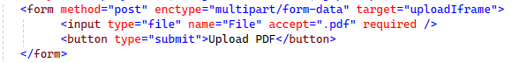

The [BindProperty] attribute allows Razor Pages to automatically bind data from HTTP requests (such as POST or GET) to a property in the PageModel. In this case:

* It binds the file uploaded in the form to the File property.
* This eliminates the need to manually retrieve the form data from Request.Form or Request.Files.

By default, [BindProperty] works with POST requests (for form submissions).

**public IFormFile File { get; set; }**

IFormFile: This is an interface provided by ASP.NET Core that represents a file sent with the HTTP request. It gives you access to the uploaded file’s:

* FileName: Name of the uploaded file.
* Length: Size of the file in bytes.
* ContentType: MIME type of the file (e.g., application/pdf).
* OpenReadStream(): Used to read the file’s content as a stream.
* CopyTo(): Used to save the file's content to a specific location.

File **Property**: This is the property bound to the file uploaded via the form. Razor Pages populates this property automatically when the form is submitted.

• **Form Submission**:

* When the user submits the form, the uploaded file is sent as part of the HTTP POST request.

• **Binding**:



* The [BindProperty] attribute ensures that the file data is automatically mapped to the File property in the PageModel.

If removing the attribute name=”File” the file won’t be processed from the request . It will throw the below user friendly message .

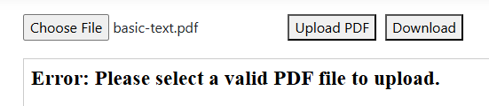

• **Processing**:

* You can then use the IFormFile interface methods (like CopyTo) to save or process the file.

**Download Click Event:**



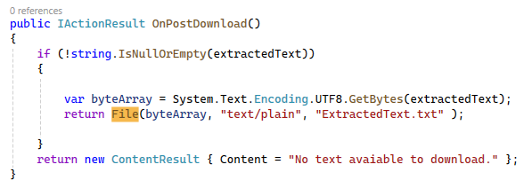

Form method should be “Post” and once the file is extracted text it will download it into local “Download” path.